ك

كلية البوليتكنيك-القادسية
قسم تقنيات الاشعه والسونار

اعداد الدكتور :مروة علي عودة
ماده :طب باطني جراحي
المرحلة:الثانية
للسنه الدراسية 2025-2026

second Course of Medicine &Surgery


/ Theoretical Medicine & Surgery…….Lecture ( 1-15) SUBMITTED BY : Dr.Marwah .A .Oudah
second Course of Medicine &Surgery


1st week
Medical part
Diphtheria
Diphtheria
Diphtheria is a disease caused by bacteria Corynebacterium diphtheria. It can cause respiratory symptoms or non-respiratory forms that affect other parts of the body, including the skin.
Symptoms
• People infected with diphtheria bacteria may develop symptoms or may have no symptoms but be carrying the bacteria and able to infect others.
• The majority of people with diphtheria will have a respiratory tract infection, with a sore throat and low grade fever in the first few days of the illness.
• Mild cases of the illness will not develop further symptoms.
• If the disease is more severe, a dense membrane will develop which could be local, for example, just on the tonsils or pharynx or could cover a wide
area of the patient’s respiratory tract. More severe cases can develop a
swollen “bull’s neck” appearance.


Complications
• Diphtheria can cause toxins to be released into the circulatory system and tissues that can cause extensive organ damage.
• Complications affecting the heart and neurological complications, such as paralysis, can develop.
The most common cause of death is suffocation by aspiration of the membrane.
Mode of transmission
Diphtheria is caught by coming into contact with droplets from the respiratory tract of an infected person particularly spread by coughing or sneezing.
Diagnosis
Diphtheria can be confirmed by laboratory tests on swabs taken from a patient’s throat and nose and blood tests.
Treatment
Diphtheria can be treated with antitoxin and antibiotics.
Prevention
An effective vaccine is available against diphtheria and mass immunization has led to the prevent the cases of infection in Iraq.


Surgical part
Head Injury
A head injury is any sort of injury to your brain, skull, or scalp. This may range from a mild bump to a traumatic brain injury.
Common head injuries include concussions, skull fractures, and scalp wounds.
Head injuries may be either closed or open.
• A closed head injury is any injury that doesn’t break your skull.
• An open (penetrating) head injury is one in which something breaks your scalp and skull and enters your brain.
Causes of head injury
• Head injuries caused by shaking are most common in infants and small children, but they can occur any time you experience violent shaking.• Head injuries caused by a blow to the head are usually associated with:
▪Motor vehicle accidents
▪Falls
▪Physical assaults
▪sports-related accidents


The major types of head injuries
1) Hematoma
A hematoma is a collection, or clotting, of blood outside the blood vessels. It can be very serious if a hematoma occurs in the brain. The clotting can lead to pressure building up inside your skull. This can cause you to lose consciousness or result in permanent brain damage.
2)Brain Hemorrhage
A hemorrhage is uncontrolled bleeding. There can be bleeding in the space around your brain, called subarachnoid hemorrhage, or bleeding within your brain tissue, called intracerebral hemorrhage.
3)Concussion
A concussion occurs when the impact on the head is severe enough to cause brain injury. It’s thought to be the result of the brain hitting against the hard walls of the skull or the sudden forces. Generally speaking, the loss of function associated with a concussion is temporary. However, repeated concussions can eventually lead to permanent damage.
4)Brain Edema
Any brain injury can lead to edema, or swelling. Many injuries cause swelling
of the surrounding tissues, but it’s more serious when it occurs in your brain.
5)Skull fracture
The skull consists of 22 bones that come together via cranial sutures. The skull hardens and fuses through development to protect the brain. A skull fracture is any break in the cranial bones. There are many types of skull fractures, but only one major cause: an impact or a blow to the head that’s strong enough to
**


break the bone. An injury to the brain can also accompany the fracture, but that’s not always the case. Learn more about skull fractures.
Common symptoms of a minor head injury
a. Headache
b. lightheadedness
c. Spinning sensation
d. Mild confusion
e. Nausea
f. Temporary ringing in the ears
The symptoms of a severe head injury include many of the symptoms of minor head injuries. They can also include:
1. Loss of consciousness
2. Seizures
3. Vomiting
4. Balance or coordination problems
5. Inability to focus the eyes
6. Abnormal eye movements
7. Loss of muscle control
8. Memory loss
When does a head injury require medical attention?
• Loss of Consciousness


• Confusion
• Disorientation
Diagnosis of head injury
• Imaging tests are commonly used to diagnose head injuries. A CT scan will help doctor look for fractures, evidence of bleeding and clotting, brain swelling, and any other structural damage.
• CT scans are fast and accurate, so they’re typically the first type of imaging.
• MRI scan. This can offer a more detailed view of the brain. An MRI scan
will usually only be ordered once you’re in stable condition.
Treatment of head injury
The treatment for head injuries depends on both the type and the severity of the injury.
Surgery
It may be necessary to do emergency surgery to prevent further damage to the brain.


2nd week
Medical part
Whooping cough and Mumps
Whooping cough (Pertussis) is a highly contagious respiratory disease caused by the bacterium Bordetella pertussis.
• This bacterium is found in the nose, throat and mouth of an infected person, and can be easily spread.
• Pertussis can occur at any age, but often causes serious problems in babies, and is usually milder in older children and adults.
• Children who are too young to be fully vaccinated and those that have not received all their vaccinations are at highest risk for severe illness and complications.
Transmission
• From person-to-person by airborne droplets and close contact with infected respiratory secretions.
• Direct, close contact with secretions from the nose, throat and mouth of an infected person.
Symptoms
• Low fever
• Runny nose

• Cough that is mild at first, then severe with times of deep, rapid coughing and a crowing or high pitched “whoop”. The cough often worsens at night.• Vomiting after coughing.
Diagnosis
The preferred method of testing is to swab the back of the nose for culture or other special pertussis testing.
Treatment
Pertussis is treated with an antibiotic, and if treated soon enough, the antibiotic may decrease the contagiousness and severity of the disease.
A person in close contact with someone who has pertussis should be given an antibiotic and/or pertussis vaccination to prevent acquiring and spreading pertussis.
Complications of pertussis
1. Pneumonia (infection of the lungs).
2. Encephalitis (inflammation of the brain).
3. Seizures and other physical and medical outcomes associated with a severe cough.
Prevention
Pertussis disease can be prevented with a pertussis vaccine.
DEPARTMENT:COMMUNITY HEALTH | ** | SUBJECT:MEDICINE AND SURGERY | ** | LECTURER: MSc Akram A. Najim

Definition | Mumps
Mumps is a viral infection of the salivary glands. It is also referred to as infectious parotitis.
Signs and Symptoms
Mumps symptoms begin 12 to 25 days after exposure.
• Swelling and pain in one or more salivary glands (sides of the cheeks and jaw).
• Fever.
• Headache
• Muscle aches and pains, fatigue and loss of appetite.
Cause
Mumps caused by mumps virus.
Diagnosis
Mumps is diagnosed with a blood test, a urine test, and a swab from the throat or salivary gland.
Complications
• Encephalitis (infection in the brain).
• Meningitis (infection in the lining of the brain).
• Painful swelling of the testicles (orchitis) or the ovaries (oophoritis).


• Pancreatitis (inflammation of the pancreas) or deafness.
• Pregnant women who become infected with mumps during the first three months of pregnancy are at risk of miscarriage.
Treatment
There is no specific treatment for mumps; therefore antibiotics will not treat this infection. Some medications can be given to relieve some of the symptoms.
Prevention
Two different vaccines can prevent mumps. They are measles vaccine and measles, mumps and rubella (MMR).
Surgical part
Meningeal injuries(inflammations and infections) Meningococcal disease is caused by bacteria called Neisseria meningitidis. It can lead to a serious blood infection called meningococcal septicemia. When the linings of the brain and spinal cord become infected, it is called meningococcal meningitis. The disease strikes quickly and can have serious complications, including death.
Risk factors
• Teenagers or young adults, and infants younger than one (1) year of age
• Living in crowded settings, such as college dormitories or military barracks

• Traveling to areas outside of the Iraq.
• Living with a damaged spleen or no spleen or have sickle cell disease
• Living with HIV
• Smokers
Symptoms
Symptoms appear suddenly – usually three (3) to four (4) days after a person is infected. It can take up to ten (10) days to develop symptoms. Symptoms of meningococcal meningitis may include:
• Fever
• Headache
• Stiff neck
• Nausea
• Vomiting
• Photophobia (eyes being more sensitive to light)
• Altered mental status (confusion)
Newborns and babies may not have the classic symptoms listed above, or it may be difficult to notice those symptoms in babies. Instead, babies may be slow or inactive, irritable, vomiting, feeding poorly, or have a bulging anterior fontanelle (the soft spot of the skull). In young children, doctors may also look at the child's reflexes for signs of meningitis.

Transmission
• It spreads from person-to-person by coughing or coming into close or lengthy contact with someone who is sick or who carries the bacteria.
• Contact includes kissing, sharing drinks, or living together.
• Up to one (1) in 10 people carry meningococcal bacteria in their nose or throat without getting sick.
Treatment
• Meningococcal disease can be treated with antibiotics. However.
• Most people need to be cared for in a hospital due to the serious, life- threatening nature of this infection.
Complications
10-15% of those who get meningococcal disease die. Among survivors, as many as one (1) in five (5) will have permanent disabilities. Complications include:
a. Hearing loss
b. Brain damage
c. Kidney damage
d. Nervous system problems
e. Limb amputations
Prevention
The single best way to prevent this disease is vaccination, the vaccines are available for people six (6) weeks of age and older.

3rd week
Medical part
Typhoid fever
Typhoid fever is a life threatening illness caused by the bacterium Salmonella Typhi.
• Anyone can get ill after exposure to Salmonella Typhi bacteria.
• Travelers visiting developing countries are at the greatest risk for getting typhoid fever.
• The infection is spread directly from person to person or through contaminated food or water.
• Some infected persons may not show any symptoms (called typhoid fever “carriers”), but can spread the bacteria to others through their feces and urine for many years.
• Animals do not carry Salmonella Typhi.
Symptoms
Symptoms start 3 days to 2 months (usually 7 to 14 days) after exposure and may include:
a. Fever


b. Headache
c. Tiredness
d. Loss of appetite
e. Red spots on chest or back
f. Constipation (in adults).
Diagnosis
Infection can be diagnosed by detecting the bacterium in the stool The bacteria may also be identified in blood and other body fluids.
Treatment
Typhoid fever should be treated with antibiotics, increase fluids and soft foods.
Prevention
• Washing hands after using the toilet or changing diapers.
• Washing hands before preparing any food or drink and before eating.• Washing hands after handling raw meat or poultry (before touching anything else).
• Avoiding unpasteurized milk and boiling all untreated water.
• Avoiding raw shellfish and unwashed, raw fruits and vegetables.
• A vaccine is available to prevent typhoid fever in certain situations.


Surgical part
Facial injury
Facial injury (Facial trauma) is an injury of the face. It may include the facial
bones such as the upper jaw bone (maxilla).
Causes
Facial injuries can affect the upper jaw, lower jaw, cheek, nose, eye socket, or
forehead. They may be caused by blunt force or be the result of a wound.
Common causes of injury to the face include:
1. Car and motorcycle crashes
2. Wounds
3. Sports injuries
4. Violence
Symptoms
a) Changes in feeling over the face
b) Deformed or uneven face or facial bones
c) Difficulty breathing through the nose due to swelling and bleeding
d) Double vision
e) Missing teeth
f) Swelling or bruising around the eyes that may cause vision
problems.


Treatment
Treatment should be done as soon as possible if the person is stable and does not have a neck fracture.
Possible Complications
Complications may include:
1.Bleeding
2.Uneven face
3.Infection
4.Brain and nervous system problems 5.Numbness or weakness
6.Loss of vision or double vision


4th week
Medical part
German measles , Small pox , Corona virus infection
German measles (Rubella)
Rubella, or German measles, is caused by a virus. This virus is found in the nose or throat of an infected person.
• Rubella is generally a mild disease, but can be very serious in pregnant women because it can harm the unborn baby.
• The number of people that get rubella in the United States has decreased significantly, with fewer than 25 cases reported yearly.
• Anyone can get rubella except those who have had rubella or the rubella vaccine.
Transmission
• From person-to- person through by airborne droplets and direct contact with infected respiratory secretions.
• By contact with the nose or throat secretions of an infected person.• Droplets from these secretions are deposited into the air whenever an infected person coughs or sneezes.
Symptoms
• Low fever
• Rash (lasts approximately 3 days or less).

• Joint aches.
• Swollen glands, especially behind the ears and the back of the neck Symptoms occur within 14
Diagnosis
Diagnosis generally depends on a blood test, urine, spinal fluid, and a throat swab can also be used to diagnosis rubella.
Rubella infection in a pregnant woman
During the first 3 months of pregnancy can result in miscarriage, fetal death, or a baby with deafness, eye, heart, liver or skin problems, or mental retardation. Babies born with these conditions have Congenital Rubella Syndrome (CRS). A pregnant woman should check with her doctor if she has been in contact with a case.
Prevention
Rubella can be prevented with a rubella vaccine. Rubella vaccine is given in the same shot with measles and mumps vaccines, and is called measles-mumps- rubella (MMR) vaccine.
Small pox
Smallpox is a contagious disease caused by a virus “Smallpox”.
• In the United States, routine vaccination against smallpox ended in 1972. Although smallpox was eradicated in 1977, there is the possibility that the illness may reappear due to an intentional bioterrorist activity.
**

• Anyone exposed to the smallpox virus may get smallpox. Even people who have been vaccinated for smallpox might become ill, because the duration of protection given by the smallpox vaccine is not fully understood.
Transmission
The virus is often contained in the saliva droplets of a person with smallpox.
Symptoms
Initial symptoms of smallpox may be similar to influenza Symptoms of smallpox include sudden onset of:
• Malaise ß fever (temperature 101°F or greater).
• Vomiting and occasional abdominal pain.
• Headache.
• Severe backache
Two to four days after initial symptoms Rash on face, arms, and legs.
Several days later
• Rash moves to the midsection of the body.
Treatment
There is no specific medical treatment for smallpox infection, although approximately two-thirds of those infected with this virus have survived previous outbreaks.

Prevention
• The smallpox vaccine is sometimes used to lessen symptoms, and may be helpful if given within four days of exposure to someone with smallpox.
• Routine smallpox vaccination is not recommended for the general public If an outbreak of smallpox occurs.
Corona virus infection(COVID-19)
COVID-19 is the disease caused by the SARS-CoV-2 coronavirus. It usually spreads between people in close contact.
• COVID-19 vaccines provide strong protection against severe illness and death. Although a person can still get COVID-19 after vaccination, they are more likely to have mild or no symptoms.
• Anyone can get sick with COVID-19 and become seriously ill or die, but most people will recover without treatment.
• People over age 60 and those with existing medical conditions have a higher risk of getting seriously ill. These conditions include high blood pressure, diabetes, and obesity, immunosuppression including HIV, cancer and pregnancy. Unvaccinated people also have a higher risk of severe symptoms.
Symptoms
People may experience different symptoms from COVID-19. Symptoms usually begin 5–6 days after exposure and last 1–14 days.

The most common symptoms are:
1. Fever
2. Chills
3. Sore throat.
People with the following symptoms should seek immediate medical attention:
A. Difficulty breathing, especially at rest, or unable to speak in sentences B. Confusion
C. Drowsiness or loss of consciousness
D. Persistent pain or pressure in the chest
E. Skin being cold or clammy, or turning pale or a bluish color
F. Loss of speech or movement.
Diagnosis
By chest X- ray, blood tests, and clinical features.
Treatment
• Most people will recover without needing treatment in a hospital.
• For those who need it, doctors will suggest treatments for COVID-19 based on the severity of the disease and the risk of it getting worse. They will consider the person’s age and if they have other health problems.

Prevention
• Avoid crowds and keep a safe distance from others, even if they don’t appear to be sick.
• Wear a properly fitted mask.
• Clean your hands frequently with alcohol-based hand rub or soap and water.
• Cover mouth and nose with a bent elbow or tissue when you cough or sneeze.
• Dispose of used tissues right away and clean your hands.


5th week
Medical part
Infection of mouth and tongue
Oral diseases and conditions
The most common oral diseases are dental cavities, periodontal (gum) disease, oral cancer, oral infectious diseases, trauma from injuries, and hereditary lesions.
Dental cavities
Worldwide, 60–90% of school children and nearly 100% of adults have dental cavities, often leading to pain and discomfort.
Periodontal disease
Severe periodontal (gum) disease, which may result in tooth loss, is found in 15–20% of middle-aged (35-44 years) adults.
Tooth loss
Dental cavities and periodontal disease are major causes of tooth loss. Complete loss of natural teeth is widespread and particularly affects older people. Globally, about 30% of people aged 65–74 have no natural teeth.
Oral cancer
The incidence of oral cancer ranges from one to 10 cases per 100 000 people in


most countries. The prevalence of oral cancer is relatively higher in men, in older people, and among people of low education and low income. Tobacco and alcohol are major causal factors.
Fungal, bacterial or viral infections in HIV
Almost half (40–50%) of people who are HIV-positive have oral fungal, bacterial or viral infections.
These often occur early in the course of HIV infection.
Oro-dental trauma
Across the world, 16-40% of children in the age range 6 to12 years old are affected by dental trauma due to unsafe playgrounds, unsafe schools, road accidents, or violence.
Common causes & risk factors
oUnhealthy diet.
oTobacco use and
o harmful alcohol use.
• These are also risk factors for the four leading chronic diseases Cardiovascular diseases and cancer.
oChronic respiratory diseases and diabetes
oPoor oral hygiene
Prevention and treatment
• Decreasing sugar intake.
• Consuming fruit and vegetables that can protect against oral cancer.



• Stopping tobacco use and decreasing alcohol consumption to reduce the risk of oral cancers, periodontal disease and tooth loss.
• Ensuring proper oral hygiene.
Infections of the tongue (Glossitis)
Types of glossitis
1.Acute glossitis
Acute glossitis is an inflammation of the tongue that appears suddenly and often has severe symptoms. This type of glossitis typically develops during an allergic reaction.
2.Chronic glossitis
Chronic glossitis is an inflammation of the tongue that continues to recur. This type may begin as a symptom of another health condition.
3.Atrophic glossitis
Atrophic glossitis, occurs when many papillae are lost. This results in changes in the tongue’s color and texture. This type of glossitis typically gives the tongue a glossy appearance.
Causes of glossitis
Allergic reactions
Allergic reactions to medications, food, and other potential irritants, these Irritants include toothpaste and certain types of medications that treat high blood pressure.



Herpes simplex infection, caused by a virus that causes cold sores and blisters around the mouth, may contribute to swelling and pain in the tongue.
Low iron levels
Low levels of iron in the blood may result in low levels of myoglobin. Myoglobin is a protein in red blood cells that’s important for muscle health, including the tongue’s muscle tissue.
Mouth trauma
Trauma caused by injuries to the mouth can affect the condition of your tongue. Inflammation may occur because of cuts and burns on the tongue or dental appliances like braces placed on your teeth.
Symptoms
• Pain or tenderness in the tongue
• Swelling of the tongue
• Change in the color of the tongue
• An inability to speak, eat, or swallow
• Loss of papillae on the surface of the tongue
Diagnosis
The patient may see your dentist or doctor for an oral examination.
Treatment
Antibiotics and other medications that get rid of infections may be prescribed if bacteria are present in the body. The doctor may also prescribe topical corticosteroids to reduce the redness and soreness.


6th week
Medical part
Gastritis and Peptic ulcer
Gastritis
Gastritis is an inflammation, irritation, or erosion of the lining of the stomach. It can occur suddenly (acute) or gradually (chronic).
Causes
• Irritation due to excessive alcohol use
• Chronic vomiting
• Stress
• Use certain medications such as aspirin or other anti-inflammatory drugs.
• Helicobacter pylori (H. pylori): A bacteria that lives in the mucous lining of the stomach; without treatment, the infection can lead to ulcers, and in some people, stomach cancer.
• Bile reflux: A backflow of bile into the stomach from the bile tract (that connects to the liver and gallbladder)
• Infections caused by bacteria and viruses

Symptoms
• Nausea or recurrent upset stomach
• Abdominal bloating
• Abdominal pain
• Vomiting
• Indigestion
• Burning or gnawing feeling in the stomach between meals or at night
Diagnosis
• Upper endoscopy. An endoscope, a thin tube containing a tiny camera, is inserted through the mouth and down into stomach to look at the stomach lining.
• Blood tests. They can also screen for H. pylori infection and pernicious anemia with blood tests.
• Fecal occult blood test (stool test). This test checks for the presence of blood in your stool, possible sign of gastritis.
Treatment
• Taking antacids and other drugs (such as proton pump inhibitors or H-2 blockers) to reduce stomach acid
• Avoiding hot and spicy foods

Peptic ulcers
Peptic ulcers are open sores that develop on the inside lining of your stomach and the upper portion of your small intestine. The most common symptom of a peptic ulcer is stomach pain.
Peptic ulcers types
A. Gastric ulcers that occur on the inside of the stomach
B. Duodenal ulcers that occur on the inside of the upper portion of your small intestine (duodenum)
The most common causes of peptic ulcers
• Infection with the bacterium Helicobacter pylori (H. pylori).
• Long-term use of nonsteroidal anti-inflammatory drugs (NSAIDs) such as ibuprofen (Advil, Motrin IB, others) and naproxen sodium (Aleve).
• Stress
• Spicy foods do not cause peptic ulcers.
Symptoms
a)Burning stomach pain
b)Feeling of fullness, bloating or belching c)Intolerance to fatty foods
d)Heartburn
e)Nausea

Risk factors
1.Smoking
2.Alcohol consumption
3.Have untreated stress.
4.Eat spicy foods.
Complications
• Internal bleeding causing anemia.
• Hole (perforation) in the stomach wall.
• Obstruction.
• Gastric cancer. Studies have shown that people infected with H. pylori have an increased risk of gastric cancer.
Diagnosis
Upper gastrointestinal (GI) endoscopy is the preferred diagnostic test in the evaluation of patients with suspected peptic ulcer disease.
Treatment
Triple therapy regimens for H pylori consist of Proton pump inhibitor (PPI), amoxicillin, and clarithromycin for 7-14 days. A longer duration of treatment (14 d vs 7 d) appears to be more effective and is currently the recommended treatment.
Prevention
Personal hygiene and avoiding alcohol, smoking, and reduce NSAIDs.

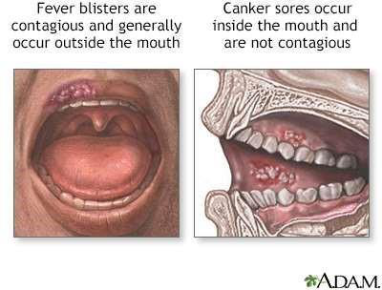
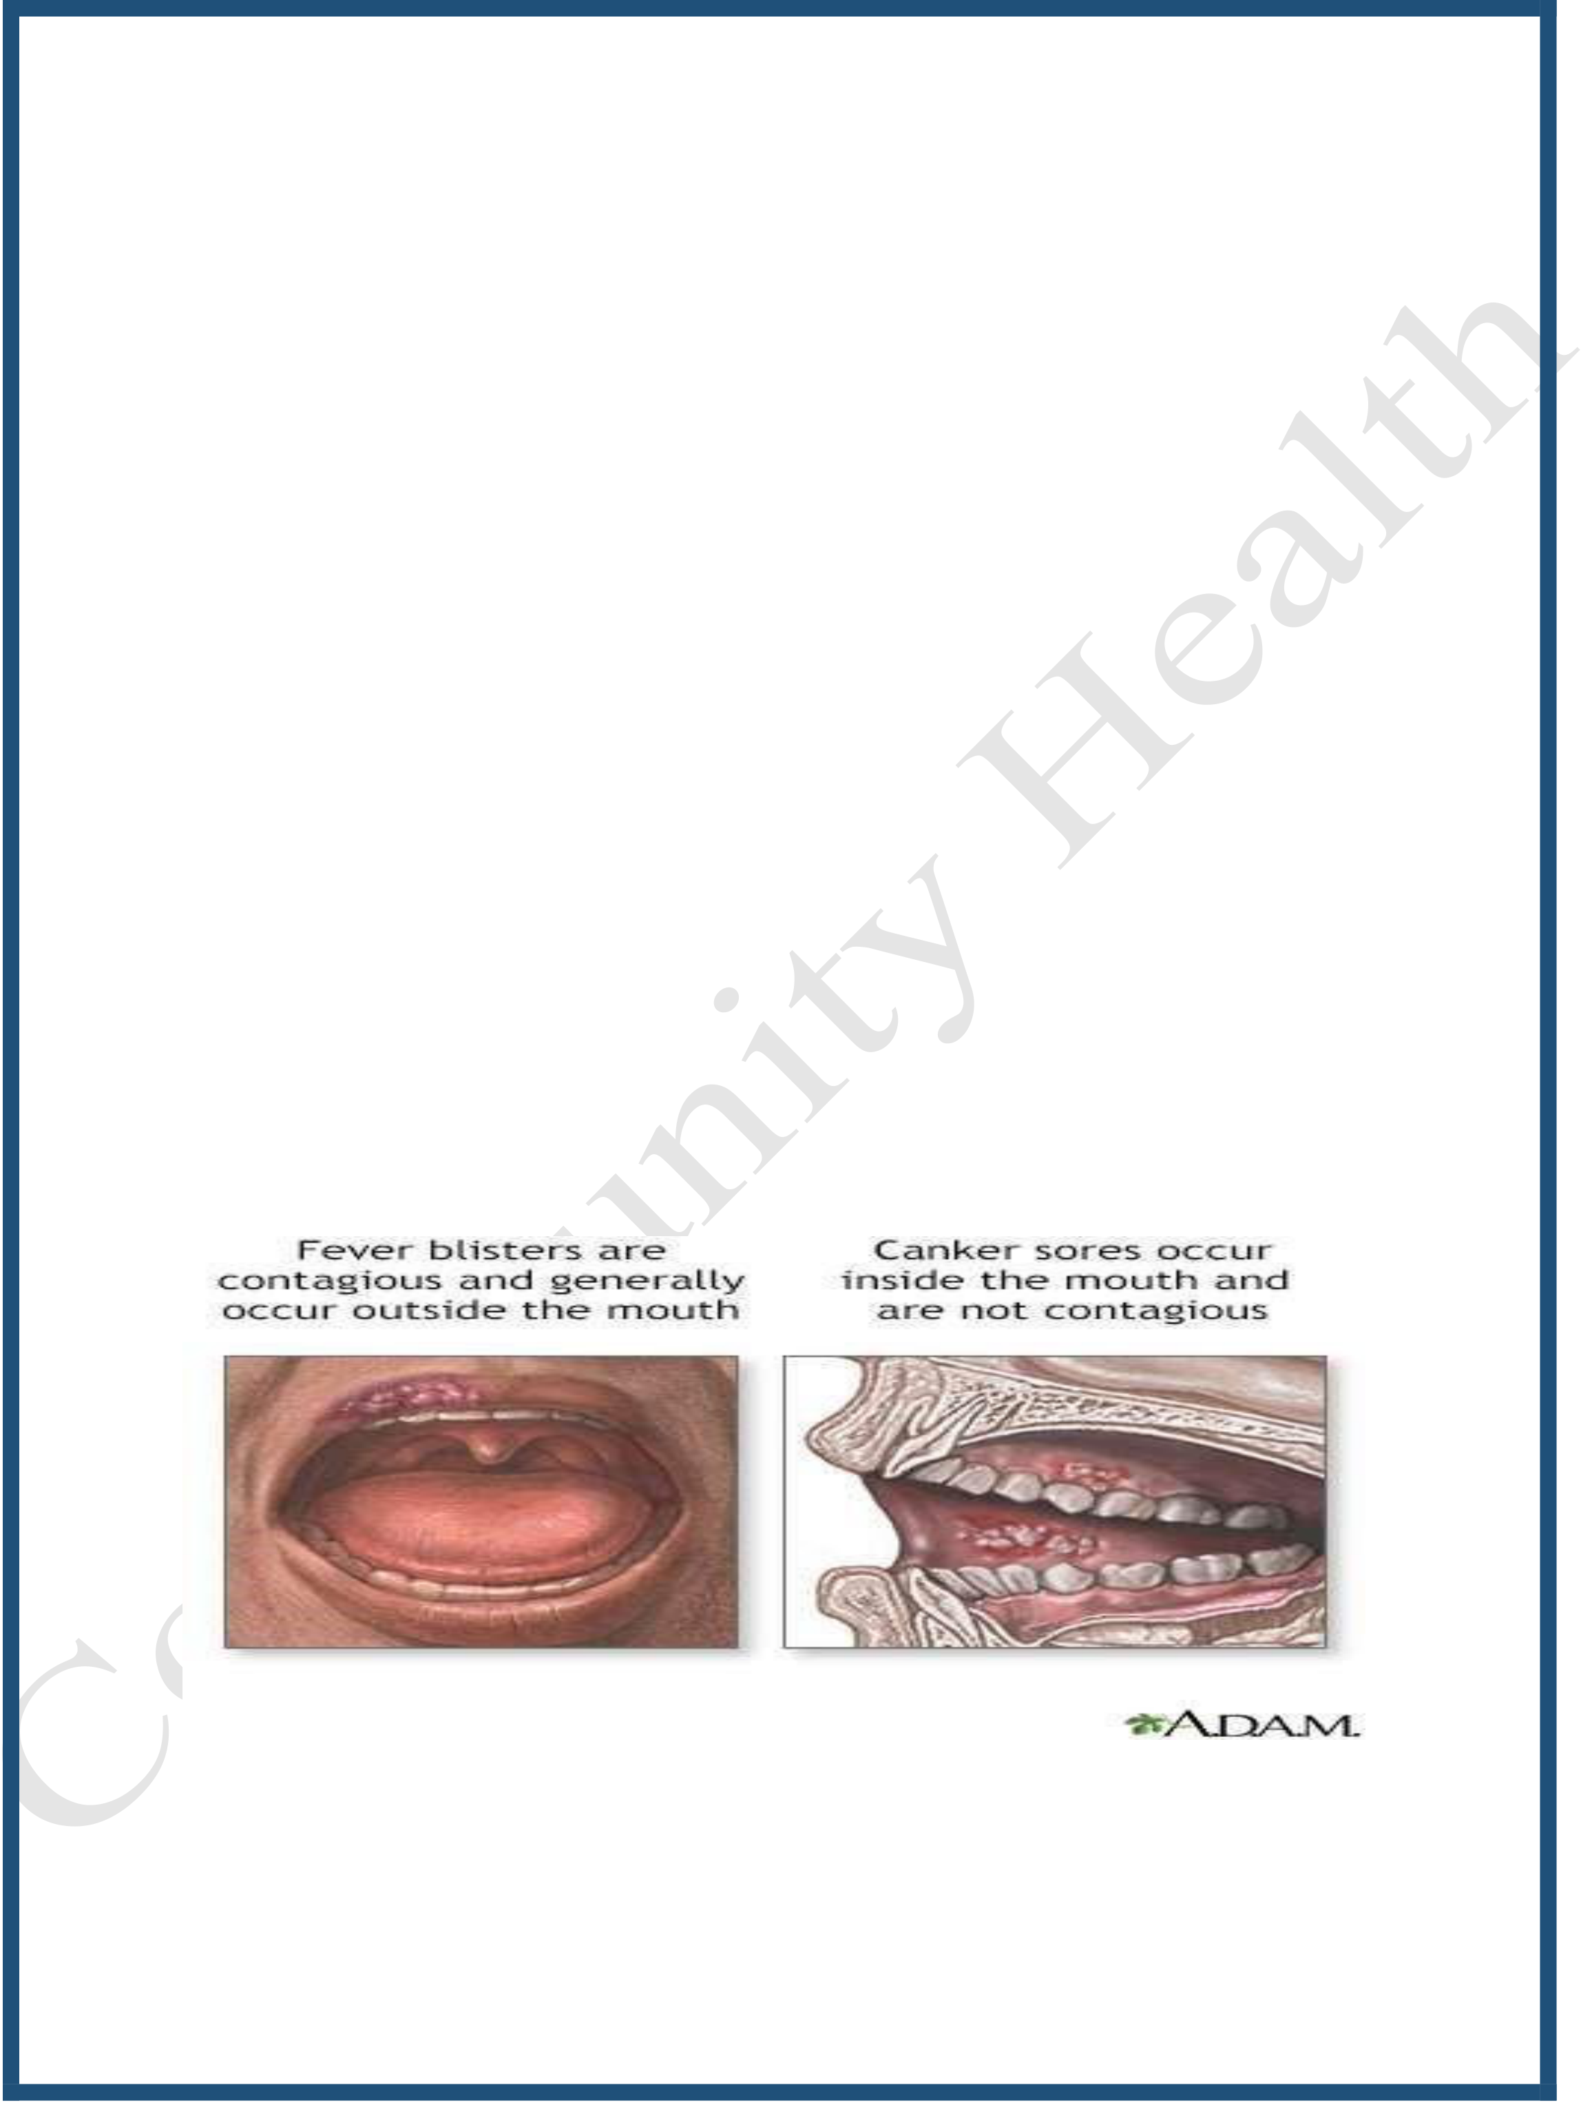
Surgical part
Gum ulcer (Canker sore)
A canker sore is a painful, open sore in the mouth. Canker sores are white or yellow and surrounded by a bright red area. They are not cancerous.
• A canker sore is not the same as a fever blister (cold sore).
• Canker sores (aphthus ulcers) are very common.
• Typically, they are a shallow ulcer with a white or whitish/yellow base surrounded by a reddish border. This severe form of ulcer can be seen in an individual with AIDS and is located in front and just below the bottom teeth.

Causes
Canker sores are a common form of mouth ulcer. They may occur with viral infections. In some cases, the cause is unknown.
• Mouth injury from dental work
• Cleaning the teeth too roughly
• Biting the tongue or cheek
• Emotional stress
• Lack of certain vitamins and minerals in the diet (especially iron, folic acid, or vitamin B-12)
• Hormonal changes
• Food allergies
Anyone can develop a canker sore. Women are more likely to get them than men. Canker sores may run in families.
Symptoms
• One or more painful, red spots or bumps that develops into an open ulcer• White or yellow center
• Small size (most often under one third inch or 1 centimeter across) • Gray color as healing starts
Treatment
• In most cases, the canker sores go away without treatment.
• Try not to eat hot or spicy foods, which can cause pain.
• Use over-the-counter medicines that ease pain in the area.


7th week
Medical part
Jaundice
Jaundice is a yellow color to your skin and the whites of your eyes.
• Jaundice is caused by a buildup of a substance called bilirubin
• Bilirubin is a yellow substance your body makes when it breaks down old or damaged red blood cells.
• Liver processes the bilirubin in order to remove it from your body.
• It removes the bilirubin by mixing it into bile, a digestive juice, and putting it into your intestines.
Jaundice can happen if something goes wrong in your liver or in the tubes that carry bile to the intestines. Bilirubin builds up in your body and makes you turn yellow.
Causes
Jaundice can happen if:
• Too many red blood cells break down at once
• The liver is damaged and can't process bilirubin properly
• Something blocks your bile ducts (tubes that carry bile from your liver to your intestines)
Symptoms
• Yellow skin

• Yellow eyes (the part that's normally white)
• Itching all over the body
• Dark urine (pee) and light-colored stool (poop). \
Diagnosis
• Imaging tests such as ultrasound, CT (computed tomography) scan, or MRI (magnetic resonance imaging)
• Sometimes, other blood tests to check for the problem causing your jaundice
Treatment
• Itching usually slowly disappears as the liver improves. If itching is severe, your doctor can prescribe a medicine that may help.
• If the cause is a blocked bile duct, a flexible viewing tube (endoscope) may be used to open it.

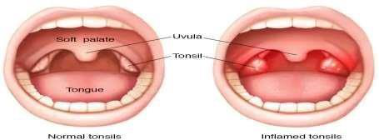
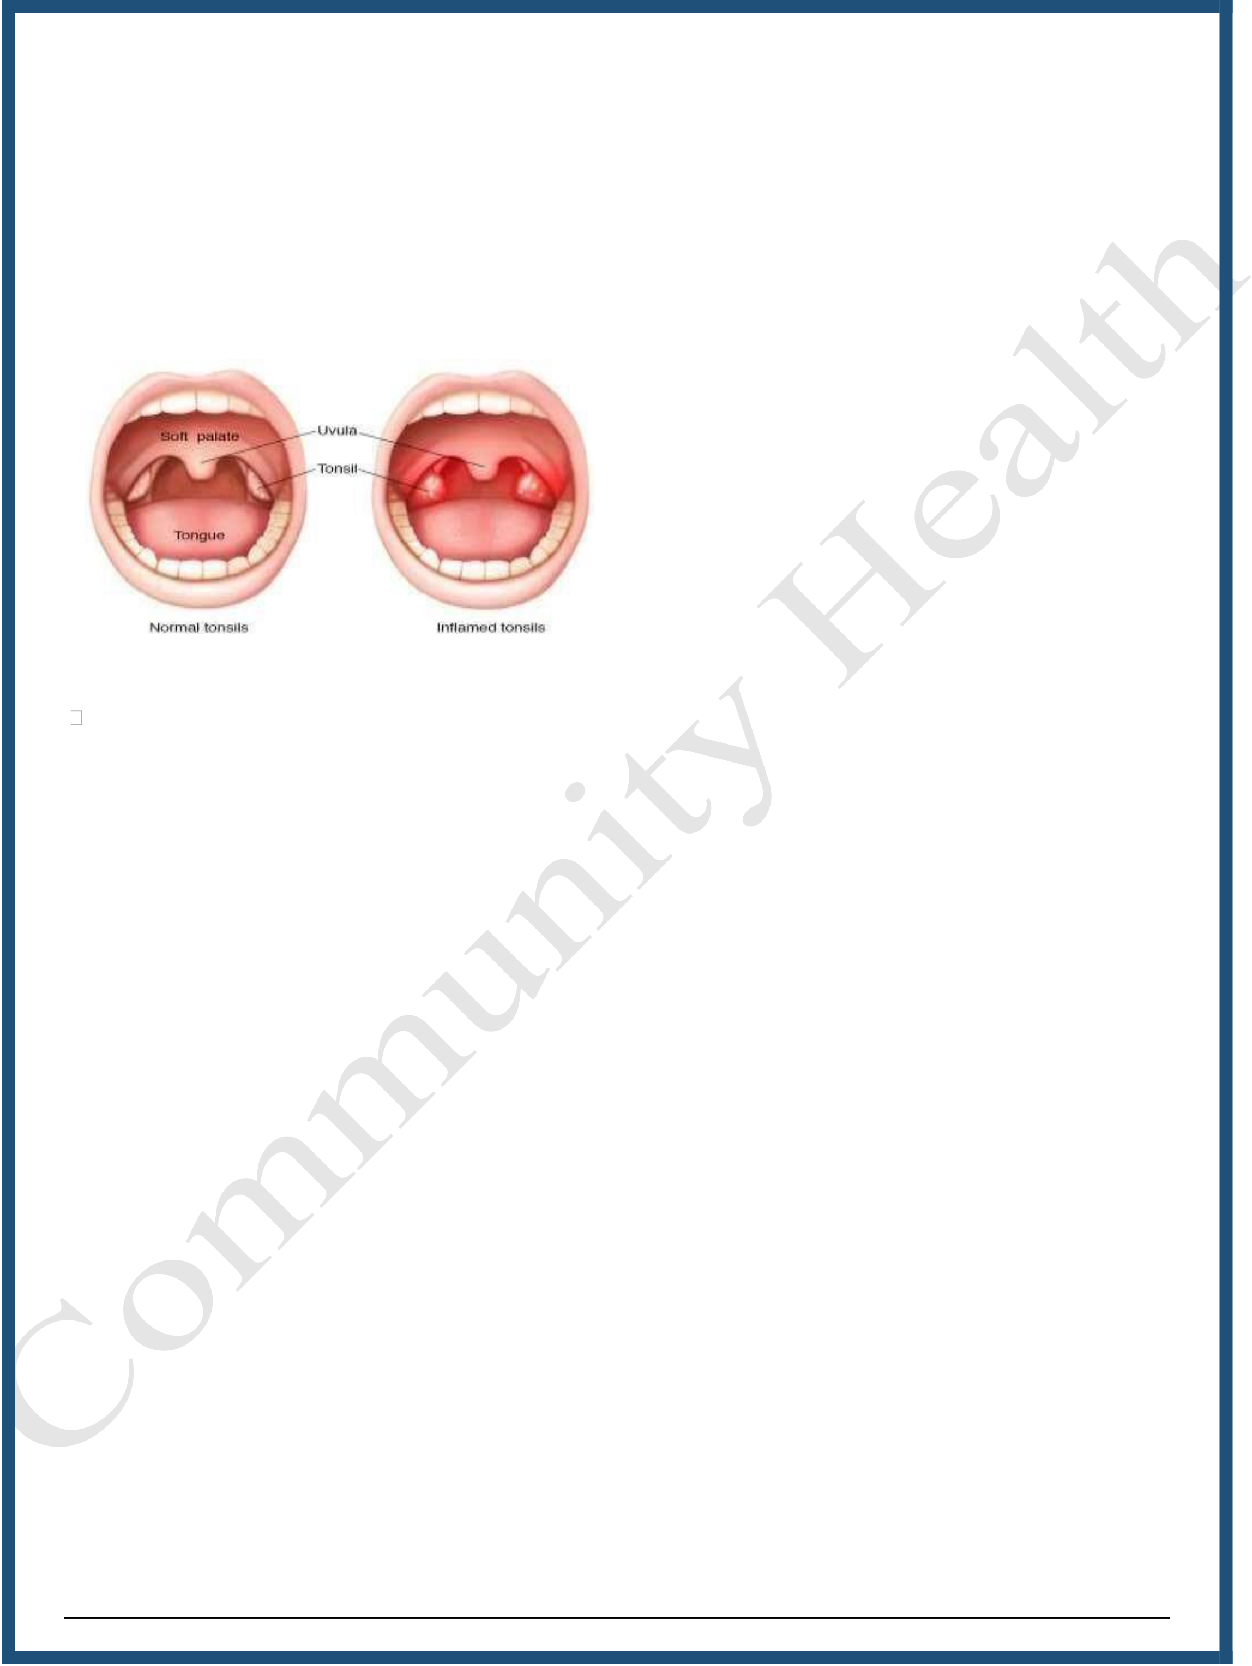
Surgical part
Tonsillitis
Tonsillitis is an inflammation of the tonsils that is usually caused by a viral infection. Less often it is caused by a bacterial infection.
Tonsillitis usually goes away after a few days. Simple treatment can ease symptoms. See a doctor if your symptoms are severe or do not get better quickly.
Symptoms
As well as a sore throat that can make swallowing painful, you may experience: • a cough
• high temperature (fever)
• headache
• feeling tired
• Swollen glands in your neck.
Causes
An infection causes tonsillitis. Most often it is a viral infection, but it can be a bacterial infection.
Tonsillitis does not usually spread between people.

Treatment
• Mild tonsillitis doesn't normally need treatment. However, your doctor may suggest that you try to drink a certain amount of fluid to stay hydrated.• Take pain relief, such as paracetamol or anti-inflammatory medicines like ibuprofen, if it is safe for you to do so.
• Use gargles, lozenges, and sprays to help soothe your sore throat.
• A short course of steroids may also be prescribed by your doctor.

8th week Medical part Heart failure
Heart failure means that your heart can't pump enough oxygen-rich blood to meet your body's needs. Heart failure doesn't mean that your heart has stopped or is about to stop beating. But without enough blood flow, your organs may not work well, which can cause serious problems.
Heart failure can affect one or both sides of the heart:
• With right-sided heart failure, the heart is too weak to pump enough blood to your lungs to get oxygen.
• With left-sided heart failure, the heart can't pump enough oxygen-rich blood out to your body. This happens when the left side of your heart becomes either:
- Too weak to pump enough blood.
- Too thick or stiff to relax and fill with enough blood.
Causes
Heart failure can start suddenly after a medical condition or injury damages your heart muscle. But in most cases, heart failure develops slowly from long-term medical conditions.
• Arrhythmia (a problem with the rate or rhythm of your heartbeat)
• Cardiomyopathy

• Congenital heart defects or other types of heart diseases that you are born with
• Coronary artery disease
• Endocarditis
• Heart attack
• Heart valve diseases
• High blood pressure
• A blood clot in the lung
• Diabetes
• Certain severe lung diseases, such as COPD (chronic obstructive pulmonary disease)
• Obesity
Risk factors
• 65 years old or older. Aging can weaken and stiffen your heart muscle.• Family health history includes relatives who have or have had heart failure.
• Have changes in the genes that affect your heart tissue.
• Smoking
• Eating foods high in fat, cholesterol, and sodium (salts)• Having an inactive lifestyle
• Alcohol use disorder (AUD)

• Illegal drug use
• Obesity
• Diabetes
• Chronic kidney diseases
• Sleep apnea
• Chronic kidney disease
• Anemia
• Iron overload disease
• Cancer treatments that can harm your heart, such as radiation and chemotherapy
Symptoms
• Feeling short of breath
• Fatigue or weakness even after rest.
• Coughing.
• Swelling and weight gain from fluid in your ankles, lower legs, or abdomen (belly).
• Difficulty sleeping when lying flat.
• Nausea and loss of appetite.
• Swelling in the veins of the neck.
• Needing to urinate (pee) often.
• Breathing problems from fluid in and around your lungs.




Kidney or liver damage including cirrhosis
• Malnutrition if fluid buildup makes eating uncomfortable or if your
stomach doesn't get enough blood flow to digest food properly
• Other heart conditions, such as irregular heartbeat and sudden cardiac
arrest
Pulmonary hypertension diagnosis
I. Medical history
II. Family health history, including relatives who have had heart failure
III. Physical exam
IV. Heart tests and blood tests.
Treatments
The treatment will depend on the type of heart failure you have and how serious
it is. There's no cure for heart failure. But treatment can help you live longer
with fewer symptoms.
• Taking medicines
• Eating less sodium and drinking less liquid to control fluid buildup
• Making other changes, such as quitting smoking, managing stress.
• Do physical activity as the health care provider recommends
• Treating any conditions that may make heart failure worse The patient
may needs heart surgery if:
- Patient has a congenital heart defect or damage to heart that can be fixed.
- If the left side of the heart is getting weaker and putting a device in your



chest could help.
Prevention
Make healthy changes in eating, exercise, and other daily habits to help prevent heart disease .
Surgical part Esophageal cancer
Esophageal cancer occurs when cells in the esophagus begin to grow abnormally.
Symptoms
Esophageal cancer can be difficult to detect early on because it may not cause noticeable symptoms until a tumor gets big enough to interfere with swallowing.
• Pressure or burning in your chest

• Indigestion or heartburn

Unexplained weight loss

• Pain behind your breastbone or in your throat Risk Factors
These factors may affect your risk for esophageal cancer:
• Sex: Men are nearly three times more likely than women to develop esophageal cancer.
• Race: The disease is three times more common among African- Americans than European Americans.

• Age: The rate of esophageal cancer rises after age 50.
• Tobacco and alcohol: These increase the risk of developing cancer.
• Obesity
• Head or neck cancers: These increase esophageal cancer risk.
• Human papillomavirus (HPV): People who are infected with HPV are at greater risk.
• Injury to the esophagus: This can cause scarring and damage cells in the area and is linked with higher esophageal cancer risk.
Diagnosis
• Endoscopy, including endoscopic ultrasound, gives the best information about the structure of your esophagus.
• Blood Tests: do complete blood count, Low red blood cells (anemia) may be a sign of internal bleeding, which sometimes happens with esophageal cancer (as well as other conditions).
• Imaging Studies: these may include a computed tomography (CT) scan or positron emission tomography (PET) scan.
Treatment
• Surgery is the most common treatment for cancer of the esophagus.• Radiation therapy.
• Chemotherapy.
• Chemoradiation therapy.

• Laser therapy.
• Immunotherapy.
Prevention
The use of tobacco products, including cigarettes, cigars, pipes, and chewing tobacco, is a major risk factor for esophageal cancer. The more a person uses tobacco and the longer it is used, the higher the cancer risks.


9th and 10th week
Medical part
Myocardial infarction and Angina Myocardial infarction (Heart attack)
A heart attack (myocardial infarction or MI) is a serious medical emergency in which the supply of blood to the heart is suddenly blocked, usually by a blood clot.
Causes of a heart attack
• Coronary heart disease (CHD) is the leading cause of heart attacks.
• CHD is a condition in which the major blood vessels (coronary arteries) that supply the heart muscle become clogged by a build-up of deposits of fatty substances, known as plaques.
• Before a heart attack, 1 of the plaques bursts (ruptures), causing a blood clot to develop at the site of the rupture.
• The clot may block the supply of blood to the heart, triggering a heart attack.
Symptoms
• Chest pain – a feeling of pressure, heaviness, tightness or squeezing across your chest
• Pain in other parts of the body – it can feel as if the pain is spreading from

the chest to the arms
(usually the left arm, but it can affect both arms), jaw, neck, back and tummy
• Feeling lightheaded or dizzy
• Sweating
• Shortness of breath
• Feeling sick (nausea) or being sick (vomiting)
• An overwhelming feeling of anxiety (similar to a panic attack)
• Coughing or wheezing
Treating heart attacks or MI
Emergency care
• While waiting for an ambulance, it may help to chew and then swallow a tablet of aspirin (ideally 300mg), as long as the person having a heart attack is not allergic to aspirin.
• Aspirin helps to thin the blood and improves blood flow to the heart.
• In hospital, treatment for a heart attack depends on the type of heart attack, and how serious it is.
Complications
• Arrhythmias– these are abnormal heartbeats. Some types can stop the heart beating
• Cardiogenic shock – where the heart's muscles are severely damaged and can no longer contract properly to supply enough blood to maintain many body functions
• Heart rupture – where the heart's muscles, walls or valves split apart

(rupture)
Prevention
• Weight reduction.
• Do regular exercise – adults should do at least 150 minutes (2 hours and 30 minutes)
• Eat a low-fat, high-fiber diet, including wholegrains and at least 5 portions of fruit and vegetables a day
• Avoid alcohol consumption
Angina pectoris
Angina pectoris is the medical term for chest pain or discomfort due to coronary heart disease. It occurs when the heart muscle doesn't get as much blood as it needs. This usually happens because one or more of the heart's arteries is narrowed or blocked, also called ischemia.
Causes
• Hardening of arteries (atherosclerosis)
• A blood clot
• Plaque in an artery that can rupture (unstable plaque)
• Poor blood flow through a narrowed heart valve
• Lessened pumping of the heart muscle
• Coronary artery spasm


Symptoms
• A pressing, squeezing, or crushing pain, usually in the chest under your breastbone
• Pain that may also occur in your upper back, both arms, neck, or ear lobes• Chest pain that spreads to your arms, shoulders, jaw, neck, or back• Shortness of breath
• Weakness
• Tiredness (fatigue)
• Feeling faint
Possible triggers of stable angina include:
• Emotional stress

• Exposure to very hot or cold temperatures • Smoking
Diagnosis

Heavy meals.

• Electrocardiogram (ECG). This test records the electrical activity of the heart. It shows abnormal rhythms (arrhythmias). And it detects heart muscle damage.
• Stress test. The test checks your heart's ability to function when under stress such as exercise.
• Cardiac catheterization. A wire is passed into the coronary arteries. Then

a contrast dye is injected into the artery. X-ray images are taken to see the narrowing, blockages, and other problems of certain arteries.
• Cardiac MRI. This test can look at the amount of blood flow to the heart muscle. It may not be available at all medical centers.
• Coronary CT scan. This test looks at the amount of calcium and plaque inside of the blood vessels of the heart. It can also show blood flow through the coronary arteries.
Treatment
Normally, this type of chest discomfort is relieved with rest, nitroglycerin or both. Nitroglycerin relaxes the coronary arteries and other blood vessels.
Prevention
• A healthy diet
• Physical activity
• Stress management
• Not smoking
• Keeping a healthy weight
• Taking medicines as prescribed
• Treating high blood pressure, high cholesterol, diabetes, and excess weight


11th week
Surgical part
Stomach cancer & Intestinal cancer Stomach cancer
• Stomach cancer occurs when abnormal cells in the stomach wall grow in an uncontrolled way.
• The stomach is part of the body’s digestive system.
• It is located in the upper abdomen.
Types
There are two main types of stomach cancer. These are named after the cell type in which the cancer first develops.
• Gastric adenocarcinoma (Gastric cancer) develops in the glandular cells that line the stomach wall.
• Gastro-intestinal stromal tumors (GIST) are rarer cancers that develop in the connective tissue in the stomach wall.
Symptoms
• Indigestion or heartburn, also known as dyspepsia.
• Nausea, feeling full or bloated even after eating small amounts.

• Pain in the stomach or abdomen.
• Unexplained weight loss.
• Difficulty swallowing – also known as dysphagia. • Anemia.
Risk factors
• Having one of a number of chronic stomach conditions, such as Helicobacter pylori (H. pylori) infection, chronic gastritis and gastric polyps.
• A diet high in salty and smoked foods and low in fruit and vegetables.
• Increasing age
• Tobacco smoking
• A family history of stomach cancer.
Diagnosis
oPhysical examination.
oExamination of a blood sample
oExamination of a stool sample.
oEndoscope to examination of the inside of the stomach and other parts of the upper digestive system.
oImaging of the stomach and nearby organs, which may include an X- ray or computed tomography (CT) scan or magnetic resonance imaging (MRI).

oTaking a | sample | of | tissue (biopsy) | from the stomach | wall
for examination under a microscope.
Treatment
Treatment for stomach cancer depends on the stage of the disease, the severity
of symptoms and the person’s general health. Treatment options can include
surgery to remove part or all of the stomach, radiotherapy and/or chemotherapy to destroy cancer cells.
Prevention
• Not smoking or quitting smoking
• Reducing consumption of smoked, pickled and salted food• Having a diet high in fresh vegetables and fruit
• Treatment of helicobacter pylori infection may be protective.
Bowel cancer (Intestinal cancer or colorectal cancer)
Bowel cancer (colorectal cancer)
• Bowel cancer is also known as colorectal cancer. Bowel cancer occurs when abnormal cells in the wall of the large bowel grow in an uncontrolled way.
• The large bowel is part of the body’s digestive system. It includes the colon, rectum and anal canal.
Risk factors
• People aged 50 and older

• People who are overweight or obese, especially those who carry fat around their waists
• People who aren’t physically active
• Alcohol consumers
• People who eat a lot of red meat (such as beef, pork or lamb) or processed meat (such as bacon, sausage, hot dogs or cold cuts)
People with family histories of inherited colorectal cancer (such as ulcerative colitis or Crohn’s disease).
Symptoms
Early stages of colorectal cancer don’t usually have symptoms. Later on, people may have these symptoms:
• Bleeding from the rectum or blood in or on the stool
• Change in bowel habit
• Stools that are more narrow than usual
• General problems in the abdomen, such as bloating, fullness or cramps
• Diarrhea, constipation or a feeling in the rectum that the bowel movement isn’t quite complete
• Weight loss for no apparent reason
• Being tired all the time
• Vomiting

Diagnosis
oStool occult blood test (FOBT)
oStool immunochemical test (FIT)
oStool DNA test (sDNA)
Treatment
Surgery is the most common treatment. When the cancer has spread, chemotherapy or radiation may be given before or after surgery.
Prevention
Some studies suggest that people may reduce their risk of developing colorectal cancer by increasing physical activity, keeping a healthy weight, limiting alcohol consumption, and avoiding tobacco.


12th week Medical part
Hypertension
• Hypertension (high blood pressure) is when the pressure in your blood vessels is too high (140/90 mmHg or higher). It is common but can be serious if not treated.
• People with high blood pressure may not feel symptoms. The only way to know is to get your blood pressure checked.
Risk factors
• Older age
• Genetics
• Being overweight or obese
• Not being physically active
• High-salt diet
• Drinking too much alcohol
• low intake of fruits and vegetables
• Chronic diseases like diabetes and kidney disease.
People with very high blood pressure (usually 180/120 or higher) can experience symptoms including:

• Severe headaches
• Chest pain
• Dizziness
• Difficulty breathing
• Nausea, and vomiting
• Blurred vision or other vision changes• Anxiety, and Confusion
• Buzzing in the ears
• Nosebleeds
• Abnormal heart rhythm.
Treatment
Lifestyle changes can help lower high blood pressure. These include: • Eating a healthy, low-salt diet
• Losing weight
• Being physically active
• Quitting tobacco
• Taking antihypertensive drugs
Prevention
• Eat more vegetables and fruits.
• Be more physically active.


• Lose weight if you’re overweight or obese.
• Take medicines as prescribed by your health care professional.
Surgical part
Appendicitis
Appendicitis
• The appendix is a small tube attached to the bowel (large intestine) in the lower right side of the belly.
• It can sometimes become blocked, causing the appendix to become swollen, inflamed, and sometimes, infected.
• Sometimes, the appendix ruptures (perforates or bursts). Children and youth with appendicitis can have:
Causes
The cause of acute appendicitis is still unclear. A number of studies have indicated that obstruction of the appendix usually occurs during appendicitis, while others dispute that obstruction is the cause of appendicitis.
Symptoms
• Dull pain centered around the navel, which progresses to a sharp pain in the lower right side of the abdomen
• Pain in the lower back, hamstring or rectum (less commonly)
• Fever

• Vomiting
• Diarrhea or constipation
• Loss of appetite.
Diagnosis
Doctor needs blood and urine texts, x-rays or an ultrasound of the belly.
Treatment
By appendectomy, is a surgery to remove a swollen and inflamed appendix


13th week
Medical part
Congenital heart disease
Congenital heart defect
Congenital heart defects (CHDs)
- Heart Defects are problems with the structure of the heart that are present at birth.
- There are many Congenital Heart Defects that vary from simple defects to more serious defects
- They can affect different parts of the heart and affect how the heart works
Types of Congenital Heart Defects: Blood usually flows from the body to the lungs, where it picks up oxygen, and then back to the body. The 2 types of congenital heart disease are:
• Cyanotic The defect causes low oxygen levels in the blood and results in
“cyanosis” or a bluish color.
• Acyanotic the defect does not result in lower oxygen levels that cause cyanosis.
Signs and Symptoms
• Shortness of breath

• Bluish skin color
• Tiredness or irritability
• Feeding Problems
• Some congenital heart defects do not have symptoms right away
Causes
The cause is unknown in many cases but genetic syndromes, infections, or health conditions in the mother, such as diabetes, can result in a higher risk of congenital heart defects.
Treatment
Depending on the heart defect, treatment may include medication, surgery or a combination.
Prevention
Avoid drinking alcohol or taking medication. Take 400 micrograms of folic acid supplement a day during the first trimester (first 12 weeks) of the pregnancy.

Surgical part
Intestinal obstruction
A bowel obstruction can be an extremely serious and dangerous condition. If not treated promptly it can cause death within a few hours. A bowel obstruction is any blockage in the bowel that prevents bowel contents from passing through.
Risk factors
• Abdominal surgery. This can increase the risk for scar tissue or other growths. ...
• Diverticulosis. This condition means that something irritates the lining of the intestine.
• Cancer.
• Inflammatory bowel disease.
• Swallowed foreign objects.
• Chronic constipation.
Symptoms
• Severe pain in the belly.
• Severe cramping sensations in the belly. • Feelings of fullness or swelling in the belly.

• Loud sounds from the belly.
• Feeling gassy, but being unable to pass gas. • Constipation (being unable to pass stool)
Complications
• Dehydration
• Tissue death in the bowels
• Abscess within the abdomen
• kidney failure
• Intestinal tears
• Pulmonary aspiration
• Sepsis
Prevention
• Eating smaller portions more often
• Avoiding large amounts of high fiber foods, such as whole grain cereals and nuts
• Focusing on eating soft or liquid meals
• Limiting the intake of caffeine, which can irritate the bowels
• Avoiding tough or stringy foods, such as celery or dried meat


14th week Medical part
Pneumonia
• Pneumonia is an infection of the lungs that can cause mild to severe illness.
• Pneumonia can be caused by viruses, bacteria, and fungi.
• Common causes of viral pneumonia are influenza and respiratory syncytial virus (RSV), and a common cause of bacterial pneumonia is Streptococcus pneumoniae (pneumococcus).
Risk factors
• Smoking
• Having underlying medical conditions (such as asthma, diabetes or heart disease) 65 years or older, or are a child younger than 5 years old.• Persons who are on ventilators are at risk for ventilator associated pneumonia.
Symptoms
• Cough
• Fever and difficulty breathing. Signs and symptoms of pneumonia can vary, depending on your age and health.

Transmission
• Breathing small droplets when an infected person coughs or sneezes into the air.
• Shaking hands or touching contaminated surfaces, then touching eyes, nose or mouth.
Diagnosis
• Physical examination
• Blood test
• Chest- x ray
Treatment
Bacterial pneumonia can be treated with antibiotics. Viral pneumonia, without evidence of bacterial infection, is not treated with antibiotics, but rather an influenza antiviral medication. This is a drug that specifically fights influenza viruses.
Prevention
• Personal hygiene
• Avoid cold air and crowded places.
• Taking vaccines that help protect against infections caused by bacteria or viruses that may cause pneumonia.


Surgical part
Liver abscess
Pyogenic liver abscess (Liver abscess; Bacterial liver abscess; Hepatic abscess)
Pyogenic liver abscess is a pus-filled pocket of fluid within the liver. Pyogenic means "with pus".
Causes.
Causes of liver abscesses, including:
• Abdominal infection, such as appendicitis, diverticulitis, or a perforated bowel
• Infection in the blood
• Infection of the tubes draining bile (bile ducts)
• Recent endoscopy of the bile draining tubes
• Trauma that damages the liver
A number of common bacteria may cause liver abscesses. In most cases, more than one type of bacteria is found.


Symptoms
• Pain in the right upper abdomen (more common) or throughout the abdomen (less common)
• Clay-colored stools
• Dark urine
• Fever, chills, night sweats
• Nausea, vomiting
• Yellow skin (jaundice)
• Right shoulder pain (referred pain)
• Chest pain (lower right)
Exams and Tests
Abdominal CT scan
• Abdominal ultrasound
• Blood culture for bacteria
• Complete blood count (CBC)
• Liver biopsy
• Liver function tests
Treatment
Treatment usually consists of placing a tube through the skin into the liver to drain the abscess. Less often, surgery is needed. Patient will also receive antibiotics for about 4 to 6 weeks. Sometimes, antibiotics alone can cure the


infection.
Complications
Life-threatening sepsis can develop. Sepsis is an illness in which the body has a severe inflammatory response to bacteria or other germs.
Prevention
Prompt treatment of abdominal and other infections may reduce the risk of developing a liver abscess, but most cases are not preventable.

15th week
Medical part Asthma
• Asthma is a chronic lung disease affecting people of all ages. It is caused by inflammation and muscle tightening around the airways, which makes it harder to breathe.
• Symptoms can include coughing, wheezing, shortness of breath and chest tightness. These symptoms can be mild or severe and can come and go over time.
• Although asthma can be a serious condition, it can be managed with the right treatment.
Common symptoms of asthma
• Persistent cough, especially at night
• Wheezing when exhaling and sometimes when inhaling
• Shortness of breath or difficulty breathing, sometimes even when resting
• Chest tightness, making it difficult to breathe deeply.
Causes
• History of other allergic conditions, such as eczema and rhinitis (hay fever).
• Exposure to tobacco smoke and other sources of air pollution, as well as


viral respiratory infections.
• Exposure to a range of environmental allergens and irritants, including indoor and outdoor air pollution, house dust mites, moulds, and occupational exposure to chemicals, fumes or dust.
• Children and adults who are overweight or obese are at a greater risk of asthma.
Treatment
Asthma cannot be cured but there are several treatments available. The most common treatment is to use an inhaler, which delivers medication directly to the lungs.
Surgical part
Liver injury (Hepatic injury)
Hepatic injury can result from blunt or penetrating trauma. Patients have abdominal pain, sometimes radiating to the shoulder, and tenderness.
Causes
• Significant impact (eg, motor vehicle crash) can damage the liver.
• Penetrating trauma (eg, knife wound, gunshot wound).
• Hepatic injuries


Symptoms and Signs of Hepatic Injury
The manifestations of severe abdominal hemorrhage, including
• Hemorrhagic shock, and abdominal pain
• Tenderness, and distention, are usually clinically obvious.
• Lesser hemorrhage or hematomas cause right upper quadrant abdominal pain and tenderness.
Diagnosis of Hepatic Injury
Imaging (CT or ultrasonography)
Treatment of Hepatic Injury
• Observation
• Sometimes embolization or surgical repair

